**Peanut Butter and Jelly Documentation**

*Below are instructions to make a peanut butter and jelly sandwich. Examples of each step can be found above each step in the process.*

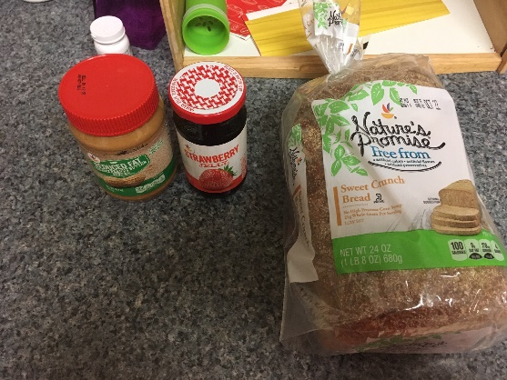

1. Get a container of peanut butter, a jar of jelly, and a loaf of bread.

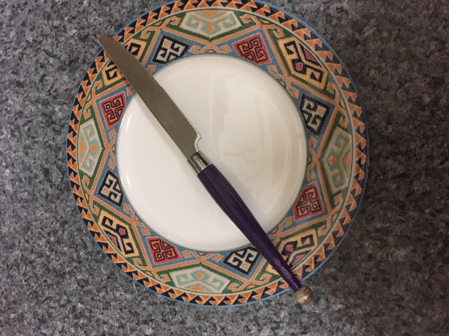

1. Get a table knife and a plate.

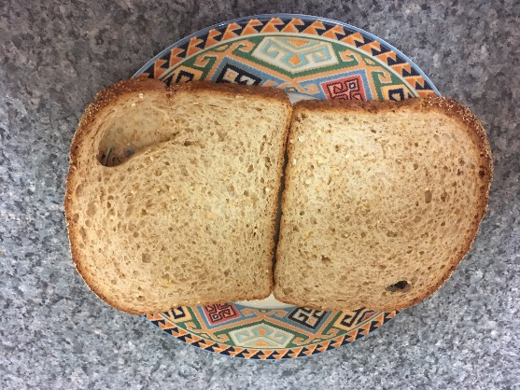

1. Take two pieces of bread out of the container containing the loaf of bread. Place the two pieces of bread parallel to each other on the plate.

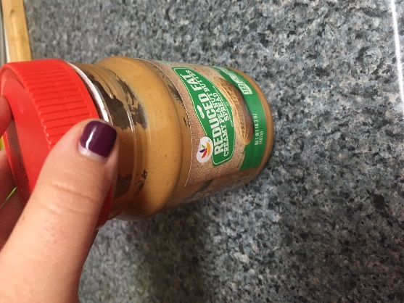

1. Open the container of peanut butter.

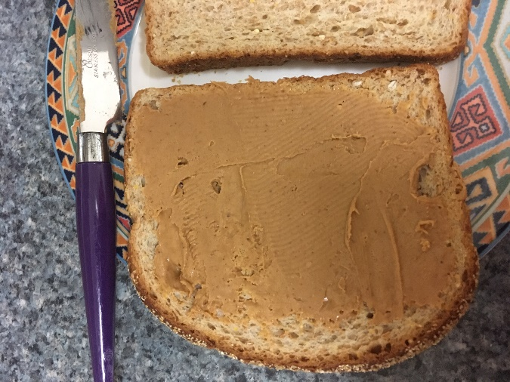

1. Use your table knife to scoop out approximately one tablespoon of peanut butter from the peanut butter container. Spread the peanut butter on one of the pieces of bread on the plate. Once it is done, it should look like the picture above this step.

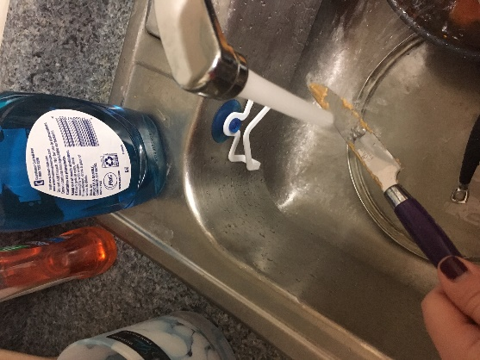

1. With water, wash off the table knife you used to scoop out the peanut butter.

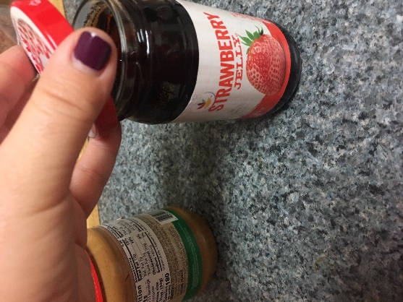

1. Open the container of jelly.

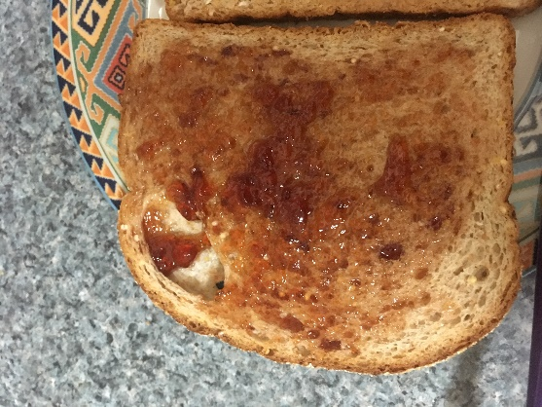

1. Use your table knife to scoop out approximately a tablespoon of jelly from the jelly container. Spread the jelly on the piece of bread that you did not spread with peanut butter. Once it is done, it should look like the picture above this step.

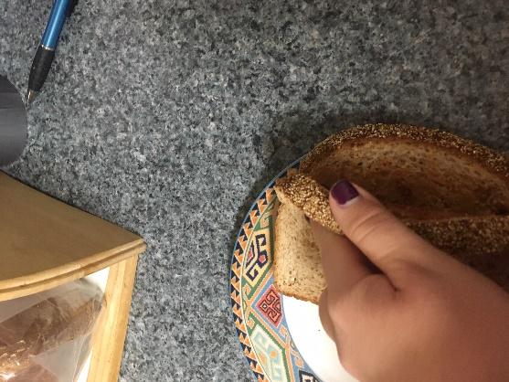

1. Pick up the piece of bread that you spread the peanut butter on. Place the piece of bread that you picked up (with the side of the bread with peanut butter side facing down) on top of the piece of bread with the jelly (with the side with jelly facing up).

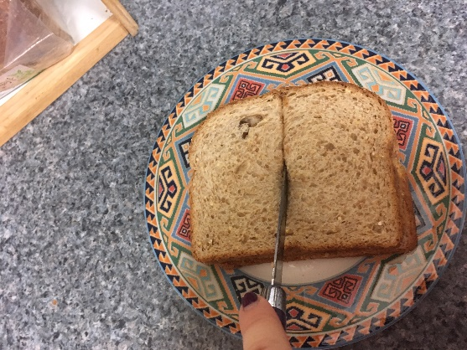

1. [Optional] Slice the two pieces of bread into two or four pieces. The picture above is the sandwich cut up into two pieces.